|  |  |
| --- | --- |
| Course Name | ITD 2313 – Script Programming |
| Instructor | Ken Dewey |
| Student Name | Jeff Kent |
| Due date | <10/10/2020> |
| Grade | 35/35 |
| Grading Comments | Excellent on all, love the comments. Ken Dewey , Oct 12 at 12:49pm |

Scripting Projects Assignment – Week 4

# Pages 99-101

## Project # 4

### Special Instructions:

1. This project is to be done in a python program file. The file needs to be submitted as part of the submission for this assignment. Place the program file into the zip file that is submitted for this assignment.

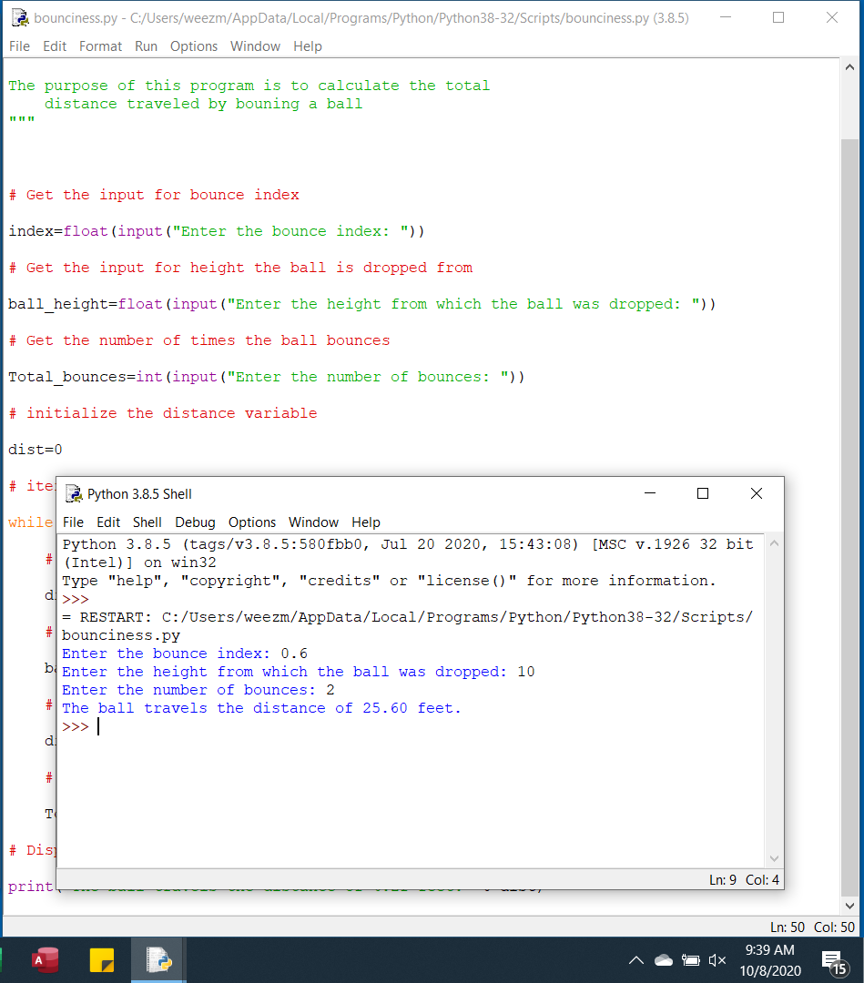

## Project # 5

### Special Instructions:

1. This project is to be done in a python program file. The file needs to be submitted as part of the submission for this assignment. Place the program file into the zip file that is submitted for this assignment.

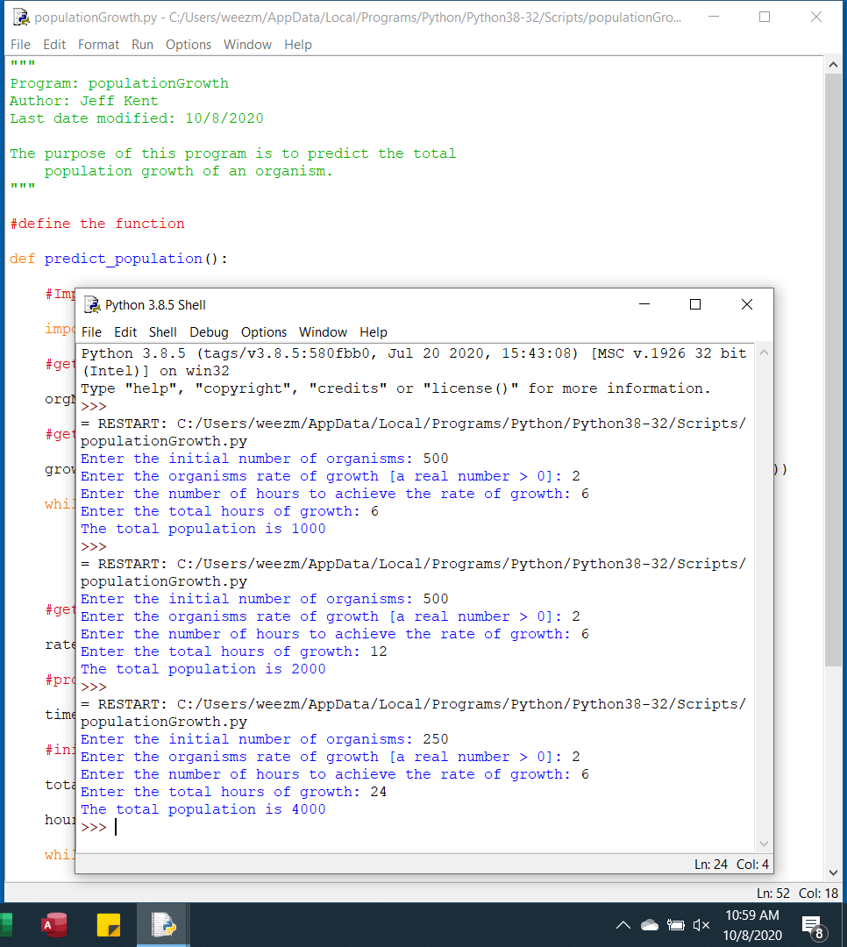

## Project # 6

### Special Instructions:

1. This project is to be done in a python program file. The file needs to be submitted as part of the submission for this assignment. Place the program file into the zip file that is submitted for this assignment.

